B2Bi and Web Services
An Intimidating Task?
This article discusses the fundamentals of Business to Business Integration (B2Bi), the need for companies to integrate their systems, the challenges of B2Bi, the usefulness of Web Services in B2Bi, and limitations in the current state of Web Services for their usage in B2Bi.
What is B2B Integration (B2Bi)?
B2B integration or B2Bi is basically about the secured coordination of information among businesses and their information systems. It promises to dramatically transform the way business is conducted between partners, suppliers and customers or buyers. All companies (large, medium, small, or new) can experience increased growth and success through tightly integrated partnerships.
Companies, from across a variety of industries, are embracing B2Bi and realizing the enormous competitive advantage it provides, through faster time to market, reduced cycle times, and increased customer service. Through integration of business and technical processes, companies are able to strengthen relationships with partners and customers, achieve seamless integration inside and outside the enterprise, gain real-time views of customer accounts, increase operational efficiencies, and reduce costs.
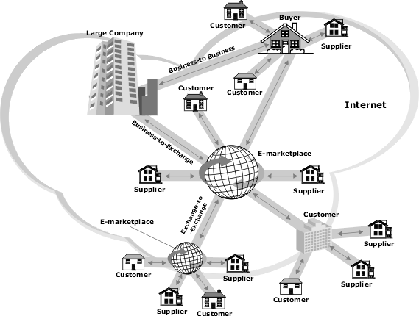
The market for B2Bi is huge. According to a recent report published in the post dot com crash era from the International Data Corporation group, by 2005 B2B e-commerce will be of the order 4.7 trillion US Dollars approximately. B2B integration is expected to yield productivity gains of over a trillion USD by 2010.
An Intimidating Task
B2Bi is easier said than done - it is indeed a daunting effort. Integration is a big challenge, especially for global corporations that have hundreds to thousands of trading partners. It is an extremely daunting effort to manage the integration of so many business processes and can turn out to be a time consuming, complex, and expensive task. With the advent of new technologies, the potential for disparity further increases and makes the exchange of electronic information even more complicated.
Essential Features of a B2B Integration Solution
Without the right selection of B2Bi solution(s) that meet your business and technical requirements, any integration implementation will be doomed. Before a company selects any B2Bi solution, it has to consider the following:
- Can the solution evolve with the company, with the industry, and with the IT industry?
- Does it offer comprehensive functionality with the flexibility to support third-party software vendors, and connect existing and new systems in a common framework?
- Does it work within scalable environments to accommodate customer and trading partner systems as well?
- Does it support open standards?
So, what are the key features that a company should look for before investing in any B2Bi software solution?
Firstly, the integration solution should be able to enable any transaction, any time - end-to-end and partner-to-partner. It should be able to fully automate real-time exchange of data between disparate applications.
Secondly, the solution should be able to conduct all transactions securely, maintain audit logs, etc.
Thirdly, the solution should support diverse sets of file formats, protocols, and security standards.
Fourthly, the solution should be based on open standards that allow a company and its partners to send transactions using any combination of applications and file formats, telecommunication pathways, communication protocols and B2B protocols, and XML standards such as RosettaNet, ebXML, OAG, Biztalk, OBI, etc. The solution should also provide support for Web Services.
Lastly, the solution should be scalable, that is, companies should be able to scale it horizontally and vertically. Further, it should offer robust load balancing features, critical to the success of large applications.
A few leading B2Bi solutions include: IBM MQSeries Integrator; Extricity; BEA eLink; webMethods B2B Enterprise; NEON eBusiness Integration Servers; Vitria BusinessWare; and Microsoft BizTalk Server.
The Role of Extensible Markup Language (XML) in B2Bi
XML has become the lingua franca of the B2B e-business revolution. It has created a mechanism to publish, share, and exchange data using open standards over the Internet. There is no doubt that in the future XML will be used in each and every B2B application.
XML is not, however, an integration solution in itself - it is just a data definition language. Without global XML standards there can be no seamless business among companies spread out all over the world. These standards are a common set of industry-specific definitions representing business processes. For XML messages to be interpreted by all companies participating in B2Bi they need to agree on a common XML-based B2B standard, which will define the document formats, allowable information, and process descriptions.
The need for industry-wide B2B e-commerce standards in vertical industries is becoming increasingly critical and obvious. Several organizations have been working to define these market-segment-specific definitions. Standards and groups such as RosettaNet, CIDX, and OASIS are making it possible for companies to share information with one another without having to completely reengineer their internal applications. These standards will automate the flow of information across all companies within a given industry, independent of the underlying software or hardware infrastructure supporting the activities related to these transactions.
Web Services and B2Bi
Web Services, which are based on XML standards, are a boon to the world of B2B, as we discussed in the previous section that XML-based standards hold the key for the success of dynamic B2Bi and its wide spread adoption by companies of all sizes. Web Services are based on the following open standards: Web Services Description Language (WSDL - to describe), Universal Description, Discovery and Integration (UDDI - to advertise and syndicate), Simple Object Access Protocol (SOAP - to communicate) and Web Services Flow Language (WSFL - to define work flows).
Thus, Web Services use SOAP based messages to achieve dynamic integration between two disparate applications. Companies use WSDL, a Web Services standard, to describe their public and private Web Services and publish their Web Services either to a private or public repository and directory using UDDI.
Essential Features of B2B Applications and Web Services
Let's discuss how Web Services fit in with some of the essential traits of B2B applications.
Distributed Transaction Management
It is very tough to maintain distributed transaction control even within disparate systems and applications within an enterprise. B2B transactions may be spread over disparate systems and applications across different enterprises, making them several times more difficult difficult to maintain and control.
In their current state, Web Services are not transactional in nature and provide basic "request/response" functionality.
Security
B2Bi requires two levels of security. Firstly, B2Bi necessitates opening up corporate firewalls to enable cross boundary communication between enterprises. Thus, whatever mode of integration is used, companies have to secure their internal network against malicious attacks through these open ports.
Secondly, the data transmitted over dedicated leased lines, such as EDI, Internet, or any other mode, has to be secured. The data may contain classified information, such as corporate information and business transaction information, and thus cannot be left unguarded.
In their current state, Web Services lack broad support and facilities for security. Thus, Web Services based B2Bi architecture may potentially have big security loopholes.
Dynamic
For companies to participate in true dynamic business with other companies, integration between the systems of the two companies has to happen in real-time. Further, this integration is only possible if B2Bi is done using open standards over the Internet.
Web Services do provide a dynamic approach to integration by offering dynamic interfaces. Web Services are based on open standards such as UDDI, SOAP, and HTTP, and this is probably the single most important factor that would lead to the wide adoption of Web Services for B2Bi.
Integration Mode
The integration mode or pattern is the most important element of B2B integration. Is the B2Bi data-, business process-, application-, function-, or portal-oriented? The answer to this question determines a lot of answers involved in the modalities and technology used for B2Bi. Typically in B2B integration, companies involved take a joint decision based on the technology available in-house, budgets, and level of synchronization needed to support business functionalities.
In this generation of Web Services, it is possible to achieve only function level integration between applications (for details on the difference between function level integration using API or RPC and Web Services, please refer to my previous article Enterprise Application Integration and Web Services).
The next generation of Web Services, however, will be functionally and technologically advanced, offering user interface encapsulation and security. They will be able to package an application and embed it into another application.
Example of Web Services for B2Bi
The following diagram shows an example of using Web Services in a B2Bi scenario. In this example, the corporate procurement application running within an application server requests quotes from multiple vendors. The procurement application of the buyer gets information about Web Services offered by suppliers using a private UDDI registry and invokes these services over the Internet to get quotes for a specific item.
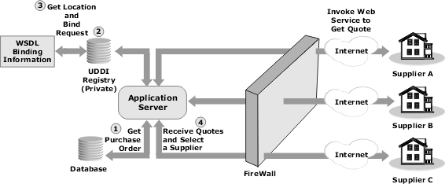
The sequence of steps is as follows:
- The Buyer's procurement application, running within an application server, has to generate a purchase order for a specific item.
- The procurement application gets information about Web Services of different suppliers for that specific item by doing a look up in the private UDDI registry.
- The location of and WSDL binding information for the Web Services is sent to the procurement application.
- The application invokes the Web Services published by the suppliers to get quotes for that item. The communication is based on SOAP over the Internet.
- The application receives quotes from different suppliers. The communication is based on SOAP over the Internet.
- The information is then analyzed, leading to the creation of the purchase order.
Conclusion
Web Services certainly have the potential of redefining the whole paradigm of B2B integration by making it truly dynamic, easily implemented in a modular fashion, and in the longer run being cheaper. The application of Web Services for B2Bi, however, will be limited if services for authentication, encryption, access control, and data integrity are not available. Web Services intermediaries that provide services such as UDDI repository hosting, security services, quality assurance of Web Services, performance checks, etc., will have a big role to play in the B2Bi space.

